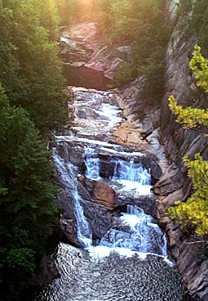
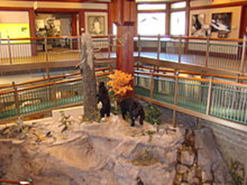
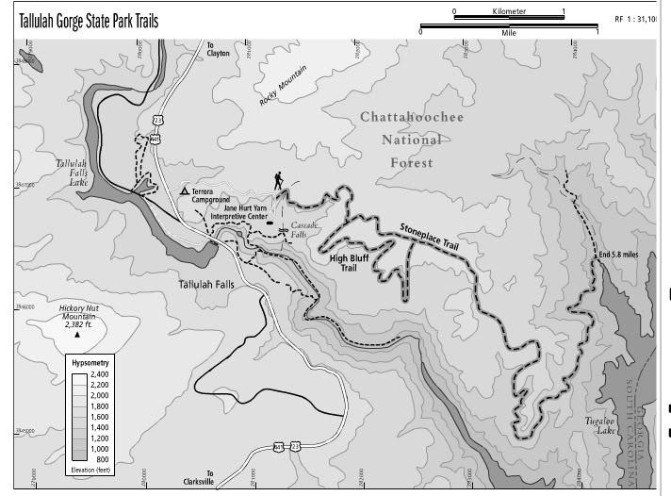

Tallulah Gorge
The best Place In Georgia
By : Victoria Lam
Mr.Cargill
Academic 4
10/27/13

Have you ever visited the best place in Georgia? If not, you’re missing out! Tallulah Gorge is considered one of Georgia’s Seven Wonders because of its beautiful scenery and amazing hiking trails. It’s a great place that has limitless fun activities that help individuals connect with nature. It is abundant in natural resources such as water from its lakes and waterfalls and trees from its forest. Tallulah Gorge is one of the greatest places for the tourism industry due to the amazing nature scenery that lures in tourists. Tallulah Gorge is a great place to visit, rivaling the Grand Canyon and will amaze anyone with its wildlife and many resources, whether or not you are a vacationer or a local.
The Tallulah Gorge was formed by the Tallulah River which sliced through the land making a two mile deep gorge. It contains a variety of landforms such as cliffs, rivers, and lakes. Of course, we wouldn’t forget one of the most famous distinguishing features of Tallulah Gorge, its great waterfalls, Tallulah Falls. The gorge also includes a State Park which attracts many people.
The Gorge has many fun activities to do in the Tallulah Gorge State Park such as hiking, camping, rafting, swimming, biking, picnicking, and fishing. It has facilities that specialize in these fields of activities. Some of these include campsites, an Interpretive Center, a suspension bridge (it scares lots of people), a lake, a beach, two picnic shelters, a tennis court, campgrounds, and a special gift shop. You may also hunt during the fall and winter, and there are certain trails that you may hunt in which include the Stone Place trail and the High Bluff trail. It is suggested that you wear bright clothing for safety reasons. You must obtain a permit first, because it’s safer for one to do so.
Do you know who Jane Hurt Yarn is? The Interpretive Center located in Tallulah Gorge is named after such a great woman. She was born in 1924 and was an environmentalist. She wanted to protect the environment and worked to protect the island and marshes of Georgia. She was the first female Vice Chairman of the Board of Nature Conversancy and had founded SAVE (Save Our Vital Environment). This Center is named and dedicated after her hard work and dedication to helping the environment. It is 16,000 square feet and contains an information center, a gift shop, and realistic nature dioramas of bears, wolves, and much more. It even has real snakes for display! All around, you can read more about the history of Jane Hurt and more on the Gorge. Cultural, historical, and natural exhibits are also included in the center. The Interpretive Center is one thing you may not want to miss if you visit Tallulah Gorge due to its many wonderful exhibits.
If you are going hiking and camping in Tallulah Gorge, you may not want to miss two campsites located in the gorge. The first, Tallulah Gorge Backcountry campsite, can be found by walking or biking. It may be easy to find, because it is west, right along the Tallulah Lake. This campsite is the best for families, because it allows pets and also provides a variety of activities and facilities such as biking, fishing, tennis (court is provided), swimming, and biking. Another campsite called the Tallulah Gorge Pioneer Campsite is located east of the park entrance. It is more intense and is literally for 18th century pioneers; it has no shower facilities, electricity, or water, however it does include pit toilets, a fire ring, and picnic tables. It is specifically, though, for groups only and has a limit of 25 to one group. It is certainly a place you’d like to camp if you’d like to experience the past of a pioneer.
If you are going hiking, however, you may want to know the trails that are in Tallulah Gorge. There are six spectacular round-trip trails:
- Gorge Floor Trail
- High Bluff Trail
- Hurricane Falls Loop Trail
- North and South Rim Trail
- Shortline Trail
- Stoneplace Trail
Each of these trails is unique and contains their own special and spectacular feature. Considering the reviews of most hikers such as, “Absolutely Spectacular” and, “Worth the Stop”, these trails are one thing you don’t want to miss when visiting Tallulah Gorge.
The Gorge Floor Trail is 2.5 miles and contains many rocks and boulders. It contains the famous Hurricane Falls Staircase which consists of 600 metal steps, and it is rated as very difficult. In fact, many hikers said, “Don’t want to do it again”, and, “I survived!” This trail will lead you to the bottom of the Gorge where you can see the falls and lake. It’s a wonderful picture-taking spot, too, and you can swim if you have a permit.
The Hurricane Falls Loop Trail is 2 miles long and only permits hikers to travel the trail. Like the Gorge Floor Trail, there are metal steps, but unlike Gorge Floor Trail, this trail is much more intense. It contains 1099 steps, and it is so intense that people with health problems are not allowed to hike this trail. Many hikers even said, “I could barely feel my legs”, and, “Never will I hike again in my entire life!” Because of its difficultness, it is famous and popular for those who dare to take the challenge of hiking the trail.
The High Bluff Trail is 4 miles long and allows mountain bikes. It contains miles of red dirt. It is rated normal and moderate by most hikers and bikers, however it is required you have a permit which you may obtain from the Interpretive Center. During the fall and winter you are allowed to hunt with a permit here. Because of this, it is a very popular trail during the cold seasons for hunters.
The Stoneplace Trail is 10 miles long and allows bikes. It is the longest trail of the six and is a rocky, hard, red dirt trail. Its difficulty varies based on what hikers say, but they mostly say it ranges from normal to difficult. You may enter the trail from Interpretive Center Road. For this trail, you must obtain a permit from the Center. This trail, like High Bluff Trail, allows a person to hunt during the cold season which is why this Trail, like High Bluff Trail, is popular during winter and fall among hunters.
The Shortline Trail is 3 miles long and allows hiking, biking, and skating. You may reach it if you walk or bike from Terrora Circle Road. It is one of the easiest trails in the Gorge and has a paved pathway. Because of the easiness, it is enjoyable, and many people can focus less on the trail and more on the view and scenery of their pleasant walk.
The last trail, North and South Rim Trail, are actually two different split trails that are considered one, because of their close distance. Both trails are specifically for hikers only and rated moderate. It takes about two hours to hike both of them, and it starts from the Interpretive Center which has a recycled rubber tire trail that you may walk on before you hike the real trail. The North Rim Trail is behind the Center and is ¾ of a mile long. You can get the best southern view of the gorge and Tallulah Falls Dam this way. On your way, you may see Oceana Falls, Bridal Veil Falls, Tempesta Falls, and Hawthorne Cascade and Pool. You may also see the Hawthrone Pool and a water compressor plant that was used in the Tallulah Falls Dam but is no longer in use today. The South Rim Trail is at the opposite side of the Center. Like the North Rim Trail, it is ¾ of a mile long, and you may see Hawthorne Pool, Tempesta Falls, Oceana Falls, and Caledoria Cascade. If you look down into the Gorge, you may see Hurricane Falls. Both of these trails are great trails to walk whether you are looking for great views of the Gorge or just going for a casual stroll.
Tallulah Gorge also features six distinguishable unique falls that are summed up to be 490 feet total. They are located southwest of the Interpretive Center. The State Park of the Gorge handles and protects most of these falls as well as their lakes, so these falls can last as long as they can. The lakes have hydroelectric dams that are built by Georgia Power to produce electricity. There is also Tallulah Falls Dam which was made along with the creation of the Lakes. If you are a tourist, you certainly do not want to miss these wonderful attractions.
There are few industries in Tallulah Gorge, but the most obvious and well-known is the tourism industry. The tourism industry began to grow popular in 1882 with the completion of the Tallulah Falls Railroad. The train tickets became cheaper and more affordable for people, and the train was fast enough to satisfy them. Because of this, thousands of people flooded into Tallulah Gorge, especially on weekends. The Tallulah Falls, however, was what really caught their attention because of its beautiful structure. Today, the hydroelectric dam which was built in the lakes is what really catches people’s attention. Their water releases are a popular site which causes the tourism industry increases dramatically, but even without the water releases, the tourism industry increased in Tallulah Gorge over the years, and this growth had given many their jobs, too. Other industries include educational, health and social services. About 26% of those industries are manufacturing and 15% Finance, Insurance, real estate, and rental and leasing, but the Tourism industry mostly dominates Tallulah Gorge.
Tallulah Gorge contains many natural resources, but none are actually pointed out as a significant or “eye-catching” resource. Of course, there is water, the main natural resource due to its spectacular waterfalls, rivers, and lakes. Because of this resource, Georgia Power was able to build several hydroelectric dams in the river. As pointed out before, there are scheduled water releases for the dams which are very popular. The Gorge also contains miniature forests that you can walk or see along the trails. These forests do not have a name due to its size, but they are big enough to call be called miniature forests. The State Park does not particularly concern itself with these resources, because there is no significant threat to them. Hopefully, these resources will last and provide homes for many species of animals to come.
Tallulah Gorge is a wonderful and both historical and natural attraction open for all to visit. I had chosen this location because of its beautiful sites, wonderful history, and spectacular attractions and features. Its crystal-clear flowing water and crisp pine and oak trees are features only Tallulah Gorge can provide. Its industries are something one can agree with, and their natural resources are abundant. Tallulah Gorge will definitely move any visitor regardless of their age.

Bibliography (all are websites):
http://www.ohranger.com/ga/tallulah-gorge/poi/tallulah-gorge-backcountry-campsite
"Tallulah Gorge State Park." TALLULAH GORGE BACKCOUNTRY CAMPSITE. N.p., n.d. Web. 26 Oct. 2013.
http://www.ohranger.com/ga/tallulah-gorge/poi/tallulah-gorge-pioneer-campsite
"Tallulah Gorge State Park." TALLULAH GORGE PIONEER CAMPSITE. N.p., n.d. Web. 27 Oct. 2013.
http://www.georgiawomen.org/_honorees/yarnj/
Georgia Women of Achievement :: Honorees :: Jane Hurt Yarn." Georgia Women of Achievement :: Honorees :: Jane Hurt Yarn. N.p., n.d. Web. 26 Oct. 2013.
http://www.ohranger.com/ga/tallulah-gorge/poi/trail
"Tallulah Gorge State Park." Trails in Tallulah Gorge (GA). N.p., n.d. Web. 26 Oct. 2013.
http://www.aboutnorthgeorgia.com/ang/Talluhah_Gorge_State_Park
"About North Georgia." About North Georgia. N.p., n.d. Web. 26 Oct. 2013.
http://www.ohranger.com/ga/tallulah-gorge/poi/trail
"Tallulah Gorge State Park." Trails in Tallulah Gorge (GA). N.p., n.d. Web. 26 Oct. 2013.
http://www.tripadvisor.com/Attraction_Review-g35300-d256196-Reviews-Tallulah_Gorge_State_Park-Tallulah_Falls_Georgia.html
"Tallulah Gorge State Park, Tallulah Falls Reviews." Tallulah Gorge State Park. N.p., n.d. Web. 27 Oct. 2013.
http://en.wikipedia.org/wiki/Tallulah_Gorge_State_Park#Activities
"Tallulah Gorge State Park." Wikipedia. Wikimedia Foundation, 10 Apr. 2013. Web. 26 Oct. 2013.
http://www.aboutnorthgeorgia.com/ang/Tallulah_Gorge_State_Park
"Tallulah Gorge State Park." Tallulah Gorge State Park. N.p., n.d. Web. 26 Oct. 2013.
http://en.wikipedia.org/wiki/Tallulah_Gorge
"Tallulah Gorge." Wikipedia. Wikimedia Foundation, 24 Oct. 2013. Web. 26 Oct. 2013.
http://www.georgiaencyclopdia.org/articles/geography-environment/tallulah-falls-and-gorge
"Tallulah Falls and Gorge." New Georgia Encyclopedia. N.p., n.d. Web. 26 Oct. 2013.
http://www.simplyhired.com/a/local-jobs/city/l-tallulah+falls,+ga
"Tallulah Falls Jobs and Industries." (GA). N.p., n.d. Web. 26 Oct. 2013.
http://www.exploresouthernhistory.com/tallulah.html
"Tallulah Gorge State Park & Waterfalls - Tallulah Falls, Georgia." Tallulah Gorge State Park & Waterfalls - Tallulah Falls, Georgia. N.p., n.d. Web. 26 Oct. 2013. http://en.wikipedia.org/wiki/Tallulah_Falls_Lake
"Tallulah Falls Lake." Wikipedia. Wikimedia Foundation, 10 Apr. 2013. Web. 27 Oct. 2013.
Images Used (all are digital):
http://en.wikipedia.org/wiki/Tallulah_Gorge_State_Park#Activities
Jane Hurt Yarn Interpretive Center. Digital image. Wikipedia.org. N.p., n.d. Web. 26 Oct. 2013.
http://alltrails.com/events/2011/07/tallulah-gorge-backpacking-over-nighter
Talullah Gorge Map. Digital image. Photobucket.com. N.p., n.d. Web. 28 Oct. 2013.
http://www.tallulahfallsgeorgia.org/
Tallulah Gorge Georgia. Digital image. Http://www.tallulahfallsgeorgia.org/. N.p., n.d. Web. 31 Oct. 2013.

