The Intolerable Acts
Article By: Victoria Lam
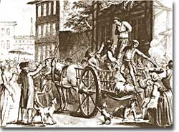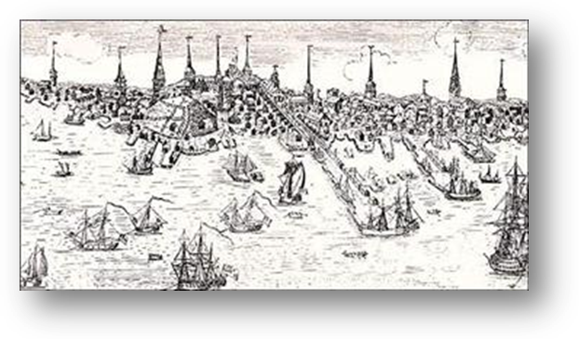
The Picture (1774) (Above) is a depiction of how the colonists reacted to taxes; they took their anger at tax collectors. The picture on the right is a drawing depicting the Boston Port Act. British ships blocked any imports or exports coming or sending from Boston.
Was there ever a rule or term someone had made that was “intolerable”? There were laws that were “intolerable” for colonists in colonial times. They were called the Intolerable Acts. These acts were significant, because they had caused an important event in history to trigger. They were made by the British Parliament and were intended to punish the colonists. For what, you ask. Well, it was for an intolerable action that the colonists had done, which made the British Parliament make the Intolerable Acts. It was certainly intolerable.
On December 16, 1773, the Sons of Liberty, a group of patriots, angry and enraged by the laws and taxes enforced by the British dumped imported tea from ships that officials refused to return back to British when colonists asked for it to be returned. They had dumped 342 chests of tea into the water, leaving merchants and traders in poverty. This event was called The Boston Tea Party. As mentioned, this was a significant event, because it had led to the American Revolution, because it had caused the Acts to be made, which led to the Revolution.
On the Morning of December 17th, officials discovered empty ships and chests of tea floating around in the water. The Parliament was absolutely furious; they could take all the protests by the colonists; however they could not take this one. The colonists had to be punished; it was the last straw. In 1774, the Parliament made four acts, which as previously stated was called the Intolerable Acts, in response to the Boston Tea Party. The fifth, the Quebec Act, was not a direct response to the Boston Tea party, but was passed the same time the legislature passed the others and was seen as an Intolerable act by the people. The acts were indeed intolerable, but it was a punishment for the colonists for their actions.
The first act was the Boston Port Act, and it was passed on March 31, 1774. It had taken effect on June 1. The act had stated that no ships were permitted in or out to the Port, meaning that colonists would have a harder time earning money or getting the resources they needed. Until payments of the damage the colonists caused were made, the Royal Navy and Army’s ships blocked the port and the colony was full of soldiers who patrolled the port. This was harsh, but the other acts were certainly harsher compared to this one.
The second act was the Massachusetts Government Act, and it was passed on May 20th, 1774. Colonists lost most of their power to vote and now the colony was controlled directly by the king or governors he assigned. Colonists could not also vote for members of the Executive Council which they were able to do before the laws were passed. The colonists were stripped of their power, because officials thought that a cause of the event was due to the lack of governmental power among the people. The colonists were also banned from having town meetings. This act greatly angered the colonists especially; however there was more to it than just being stripped of power.
The third act was the Administration of Justice Act (referred to the Murder Act by colonists, because officials could get away with murder), and it was passed on May 20, 1774. It stated that any British officials charged with Capital offences could be sent to another colony or be sent back to Britain for trial. This act was meant to protect the officials, because the government felt it would be unfair to hold trials for an official with colonists watching, because they could easily lie if they didn’t like the official. This seemed fair, because some of the colonists really disliked the officials, but the colonists were also very angry at this law, but if you’d ask me, the third act was potentially better and less harsh than the other acts.
The fourth act was the Quartering Act was passed on June 4, 1774. Unlike the old Quartering Act of 1765 which stated that soldiers could be housed in unused buildings and inns and owners had to provide free food and supplies, the fourth act had stated that soldiers could be housed in private homes of colonists. Obviously, this made the colonists angry. Soldiers could be housed in private homes, which today we could refuse, but in 1774 was a law. It was also an invasion of privacy and soldiers that were lazy or with rotten personality still received free food and supplies. Also, the soldiers could have done anything in the house, including illegal things to the house or the owner. Doesn’t that sound absolutely terrible!?
The fifth act was the Quebec Act and was passed on June 22, 1774 and put into action on May 1, 1775 (that’s right; about a year later). As stated previously, this was not a direct response to the Boston Tea Party. Basically, it expanded Quebec and let them have religious freedoms which appealed to the Catholic Church. The land expansion included Illinois, Indiana, Michigan, Ohio, Wisconsin and Minnesota. This was considered an intolerable act, because some of the colonies and colonists had already settled there. Even George Washington was angry, because it did not let other colonies expand their land and give them a chance to explore. This act had not been directly towards the Tea Party, but everyone was affected and angry, so it was considered intolerable.
The colonists were obviously angry and enraged of these acts, however they did not last very long or at least they did not stop the colonists. For example, the other thirteen colonies began to send supplies to Boston after the Port Act was passed. This was one of the first time the thirteen colonies worked and came together. Also, in 1778, the British had taken down the Massachusetts Government Law in an attempt to stop the American Revolution. The Quartering Act was no longer in effect on March 27, 1776. The Administration of Justice Law did not last long either due to the American Revolution. The laws barely scratched the colonists at all.
As repeated constantly, the American Revolution had followed shortly and many laws were repealed in an attempt to stop the Revolution. The unification of the thirteen colonies and the people had overcame the British and their King and brought independence to the colonies along with the famous Declaration of Independence which was signed by a variety of historical figures. The Intolerable Acts was a significant key to independence for the colonies, and without the acts, we would probably not have our modern clothes or technology (though some 18-th Century colonists might disagree and would strongly disagree), and we would be wearing fancy coats with funny-looking hats and many other different races of people would probably not be here either.

